**……………CSCE 5320 Scientific Data Visualization**

**………………………………ICE-5**

**…………………....The Shapes Of Data…………………...**

# Create a CSV dataset and create a URL link for your dataset. Submit the URL

The dataset on DC public schools includes markers that indicate the location of public schools in the District of Columbia. Originally developed for use by the DC public schools, the dataset was later incorporated into the DC Geographic Information System by the Office of the Chief Technology Officer. The dataset encompasses all publicly owned schools and learning centers. Private and charter schools are not included in the dataset. The school locations were identified based on information in a database maintained by the DC Public Schools' Office of Facilities Management, and the dataset is current as of the 2018-2019 academic year.

I have downloaded an Excel with DC Public school data.

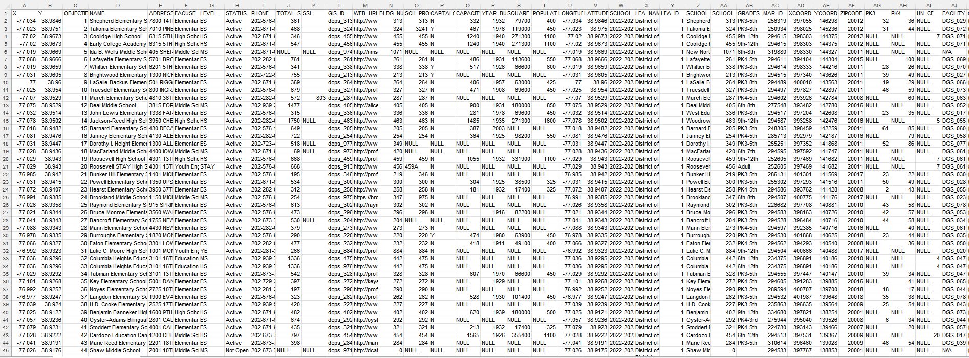

I have converted the excel into a csv file as shown below.

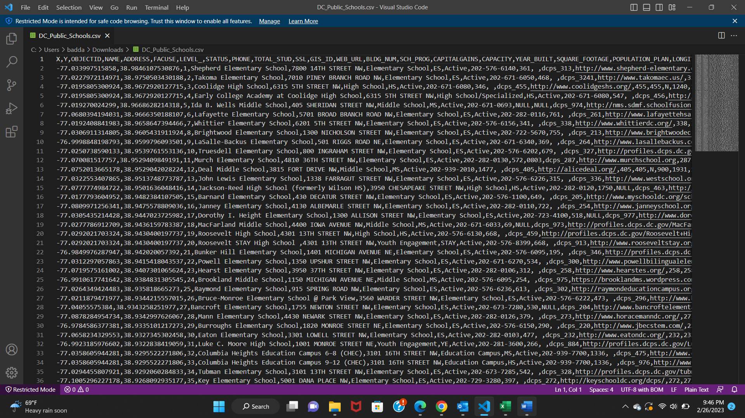

As we can see below, there are a few columns that have NULL values for all the records. We shall remove these columns.

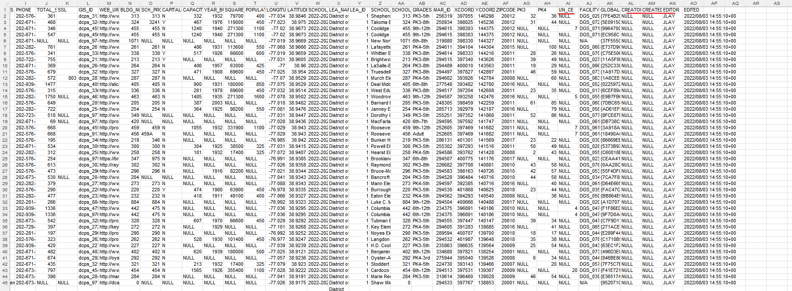

Deleted few columns that have redundant data for all rows.

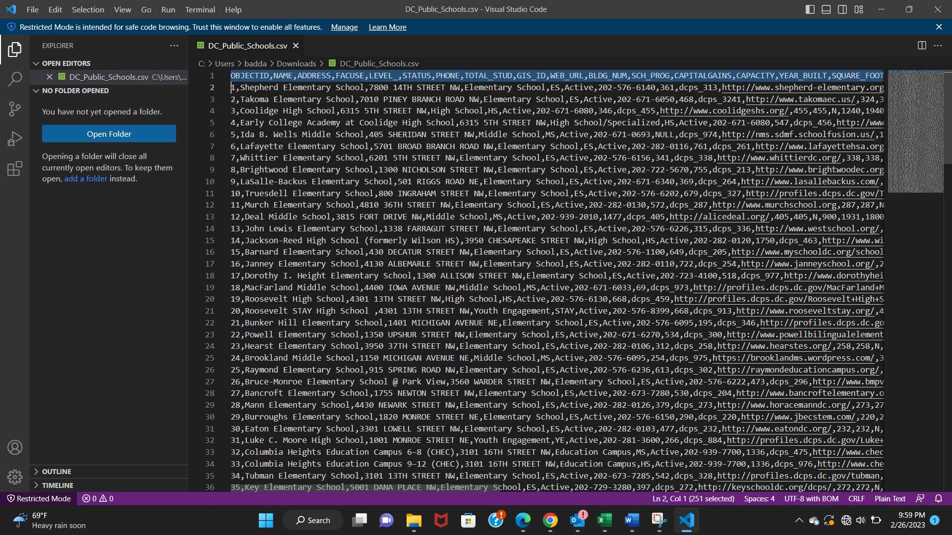

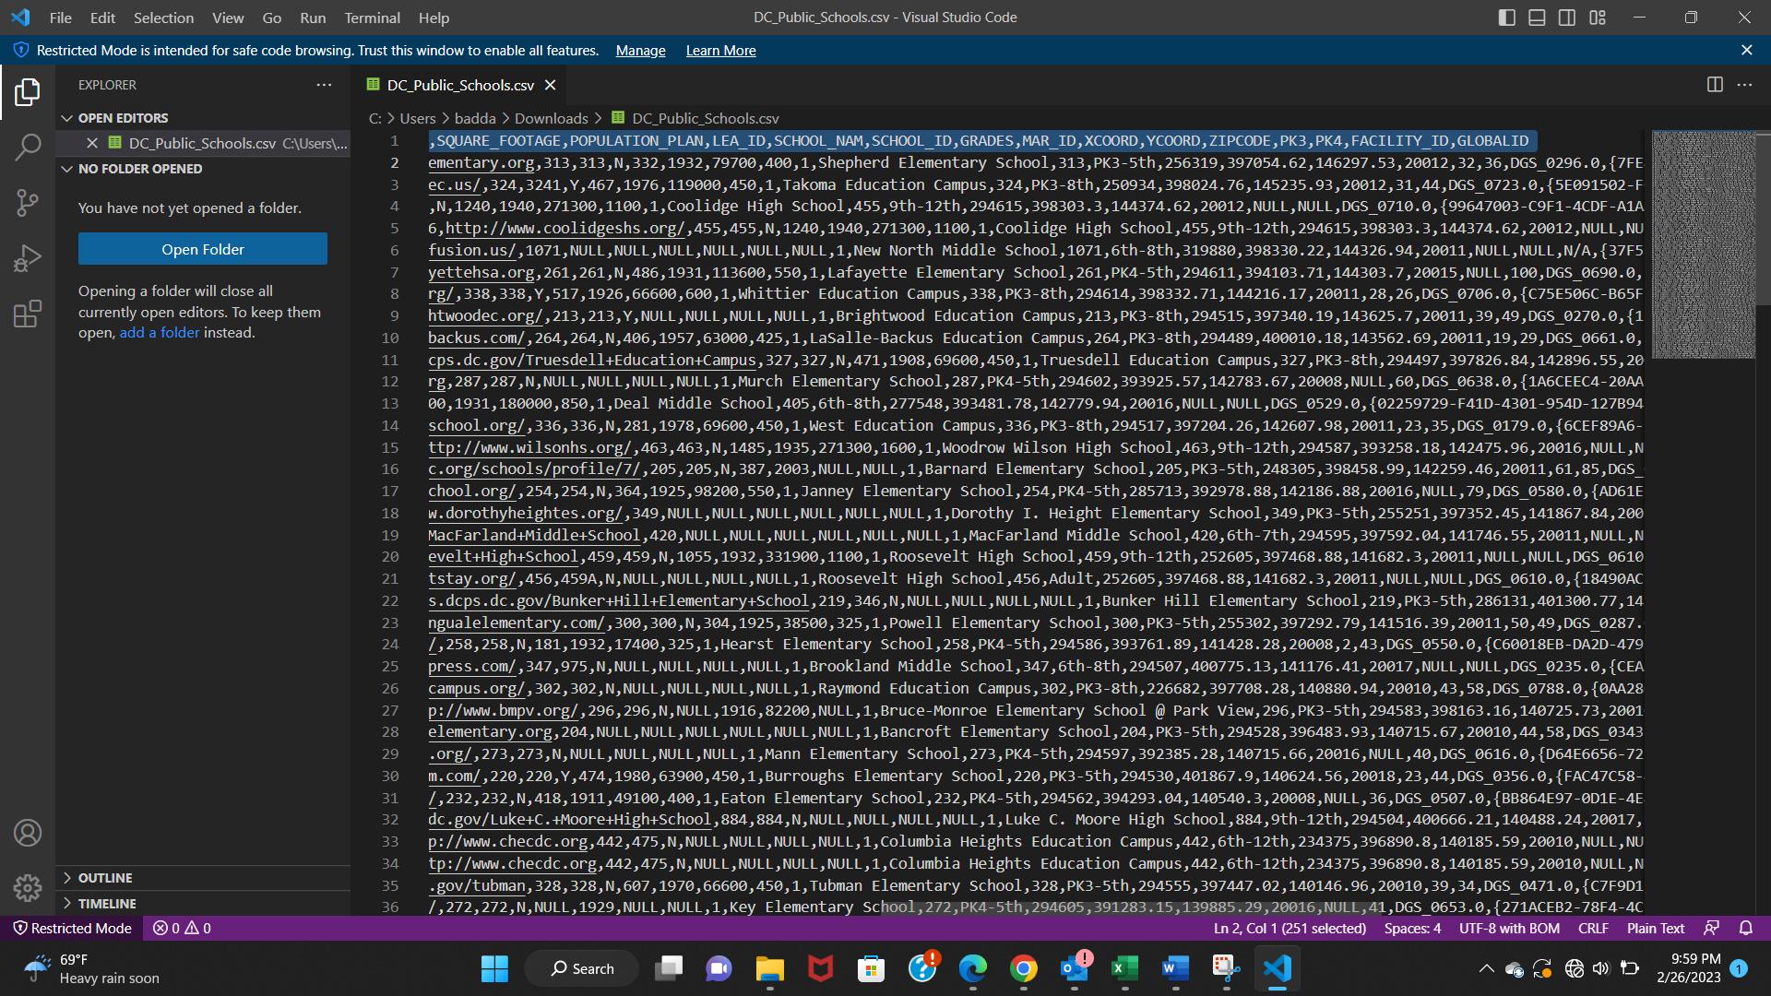

We can observe that few rows have many NULL values, removing such rows. Below are few such rows that have been highlighted with red underline.

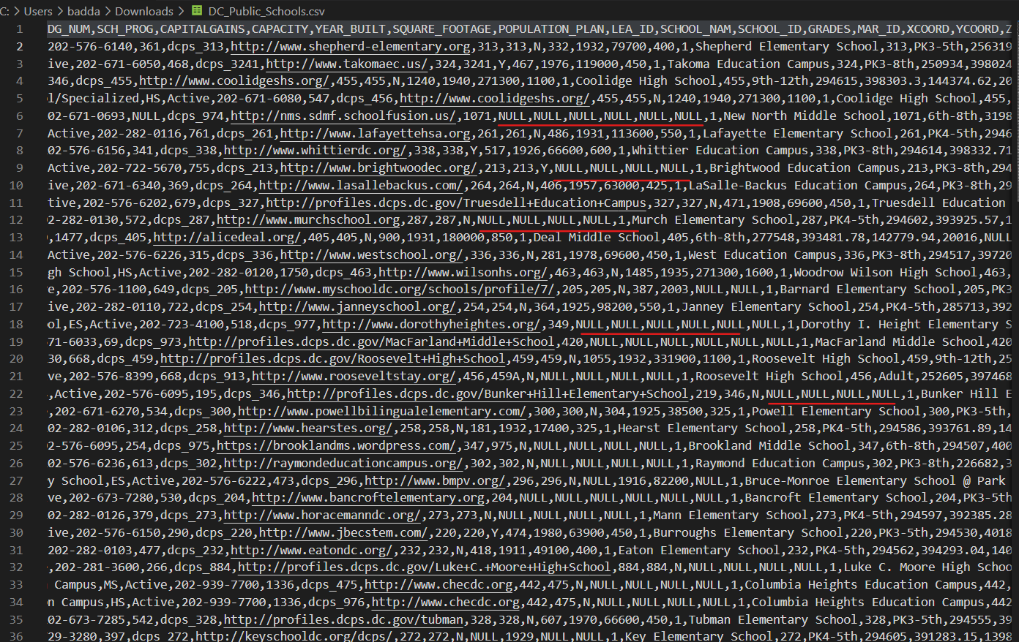

Below is the final csv file without any junk data in it. This clean data has 27 columns and 55 rows.

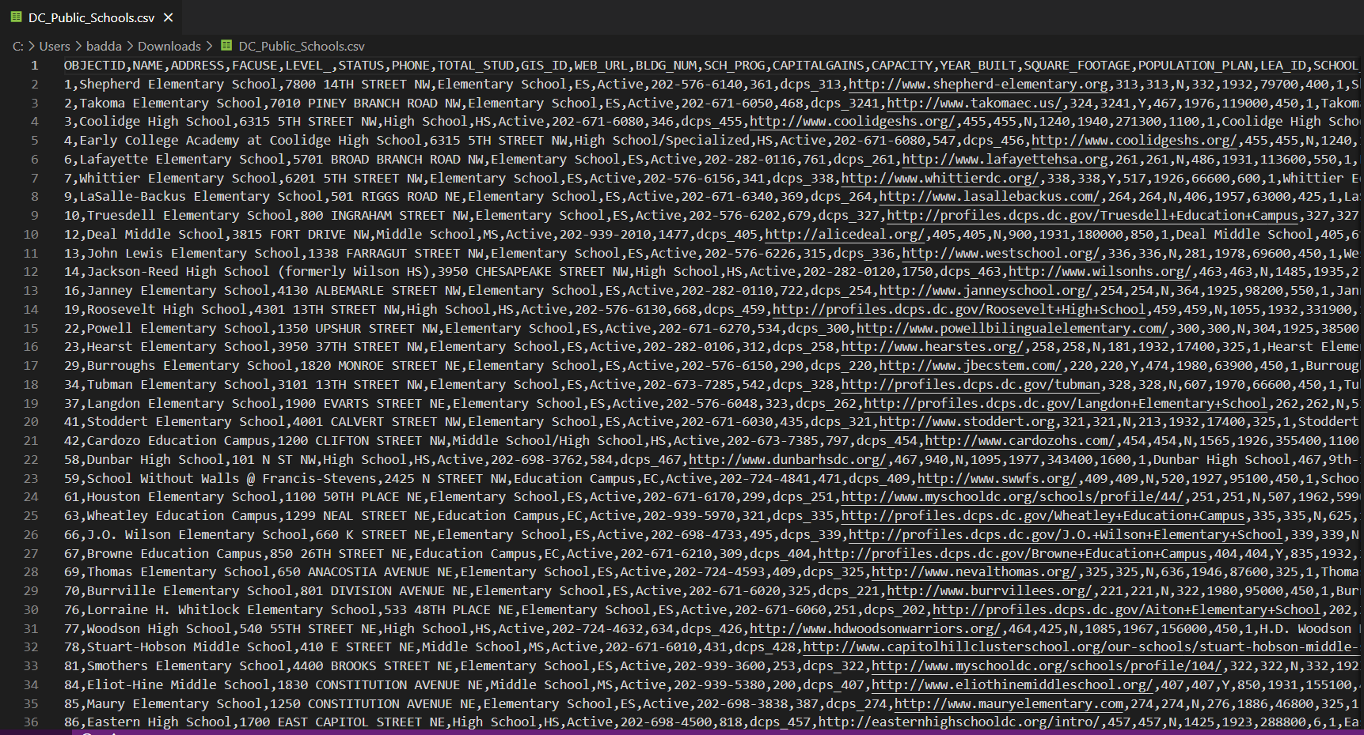

Now we load this clean data into the GitHub Gist, I have created a GitHub Gist as “DC_Public_Schools.csv” and pasted the csv data from my computer onto the GitHub Gist as shown below. I have saved it as a public Gist.

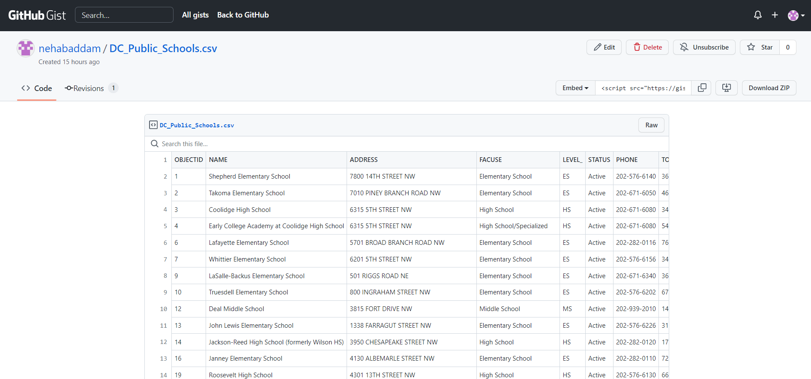

If we click the “Raw” button, the raw data in loaded on another tab of the browser as shown below.

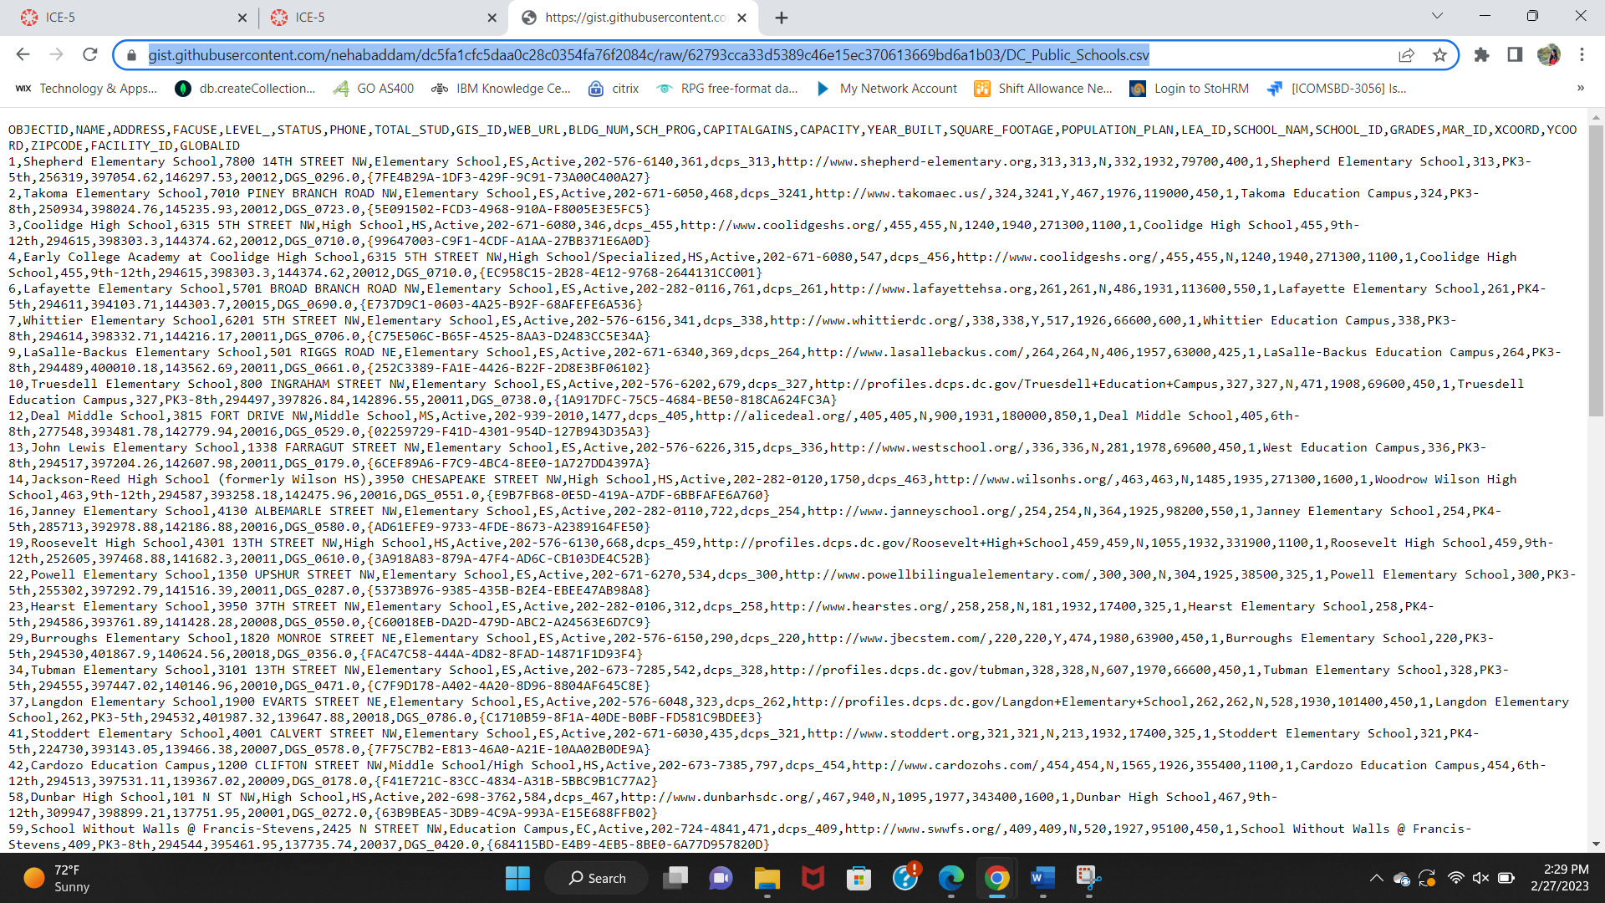

**Link to the “DC_Public_Schools.csv” raw data:**

<https://gist.githubusercontent.com/nehabaddam/dc5fa1cfc5daa0c28c0354fa76f2084c/raw/62793cca33d5389c46e15ec370613669bd6a1b03/DC_Public_Schools.csv>

# Create an HTML code and load the CSV data and use your own VizHub account. Summarize the data on your webpage. Add CSS style for your webpage.

Firstly, I created a Viz by forking a “HTML Starter”. I have created an “index.html” page with many tags as shown below. For every tag that is opened there is a closing tag.

1. Html Tag: This tag opens the HTML code logic.
2. Head Tag: The head tag consists of the header contents of the html page and the links to external files.
3. Link Tag: Here I have used Link tag to link the CSS file.
4. Script Tag: It is used to load the JavaScript file to access the d3 functions.
5. Body Tag: The bod tag contains the main web-page contents.
6. Center Tag: The center tag makes sure that the contents are aligned to the center of the screen.
7. Division Tag: Division Tag is used to create a small division in the webpage for the heading.
8. Pre-Element Tag: It is used to load the result of the d3 function, that loads the “DC_Public_Schools.csv” and calculates the size of file, number of rows, number of columns and fetches all the column headings. This basically shows the summary data of the file.
9. Script Tag:

This is a script written in JavaScript that uses the D3.js library to load and process a CSV file containing public school data from the CSV file that we have loaded onto the GitHub Gist. It then uses the D3.js function d3.csv() to fetch the data from the URL and parse it as CSV. Once the data is loaded, the script generates a message that displays information about the dataset. The message includes the size of the data in kilobytes, the number of rows and the number of the columns, and the names of the columns in the dataset.

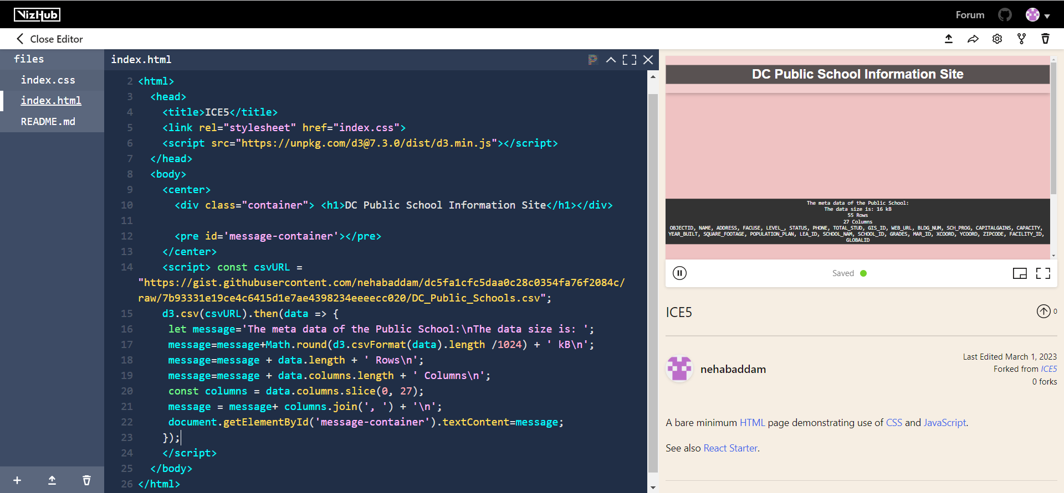

For the above HTML file, I have created the below CSS. It consists of five elements.

1. Body: The body element, is for the body tag in HTML, here we are defining the font style, background details, margin, and padding.
2. Header 1: It is for the Header 1 tag of the HTML. It defines the font alignment, padding, background color and color.
3. Header 4: It is for the Header 4 tag of the HTML. It defines the font alignment, padding, background color and color.
4. Pre: It is for the Pre-Tag of HTML code, It defines the margin, padding, background color, color, white spaces, text alignment and border.
5. Container: This defines the container class, with margin, padding, background color, box shadow, and text alignment.
6. btn: It is for the button class, it defines display, padding, font details, text details, border, color, background-color, cursor, transition, border-radius, margin, and hovering effect for the same button is also defined.

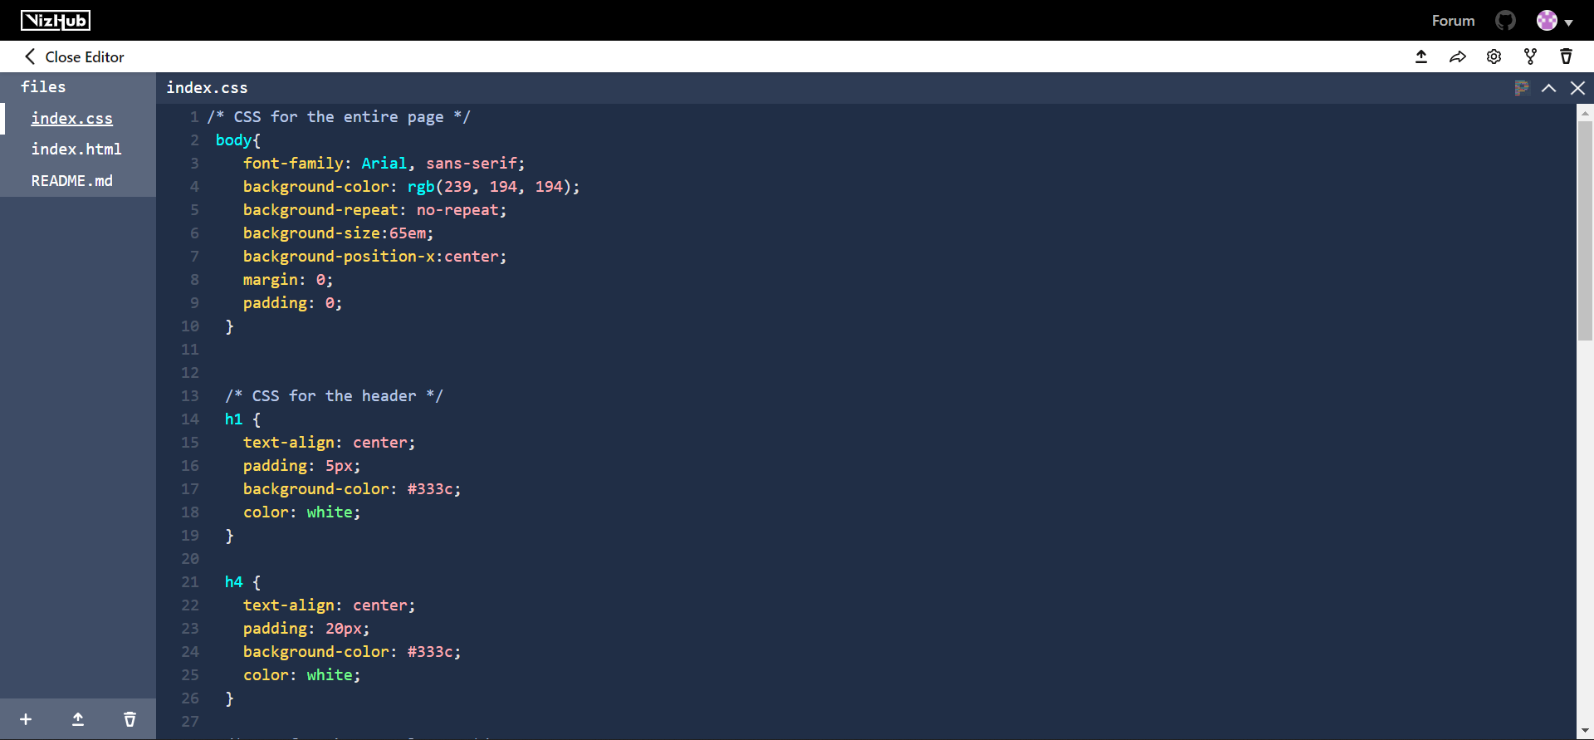

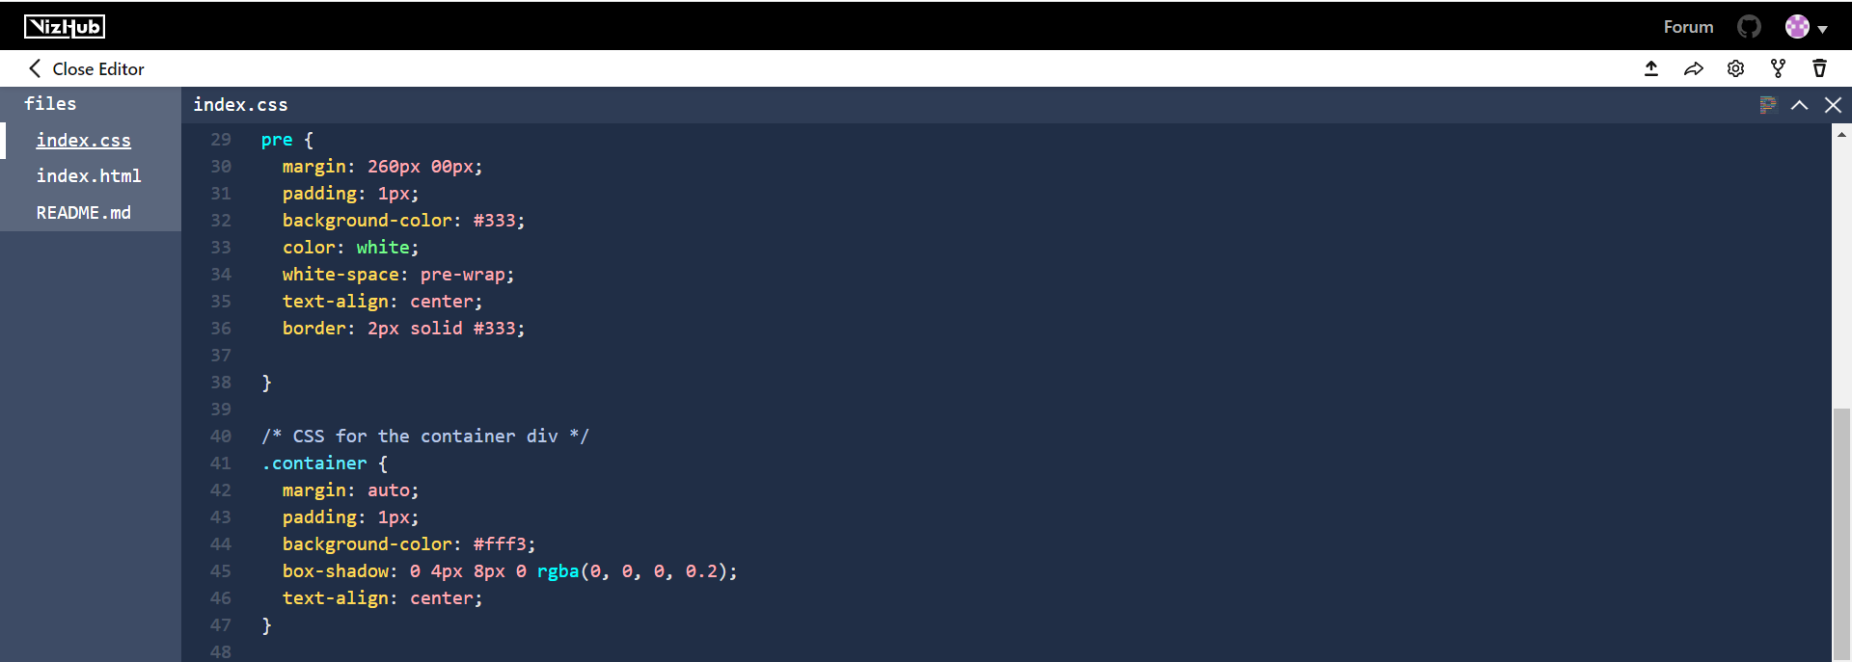

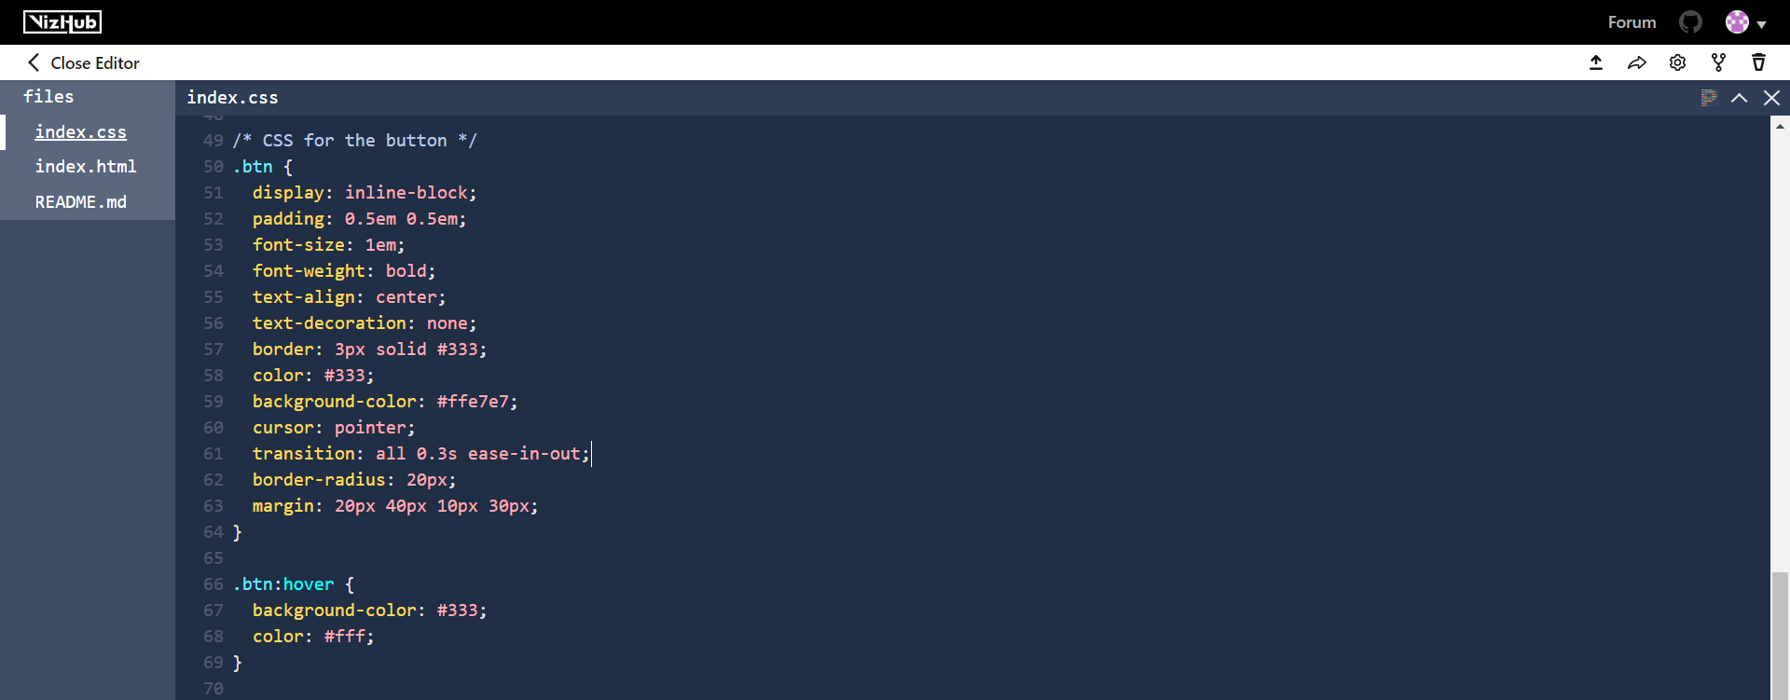

Below is how the HTML web page looks like with the defined CSS. As you can see the CSV data from the “DC_Public_Schools.csv” file from the GitHub Gist is loaded using the d3 function. It shows the data summary of the file, the size of the file, Number of rows, Number of Columns and Column headings are also displayed for all 27 columns.

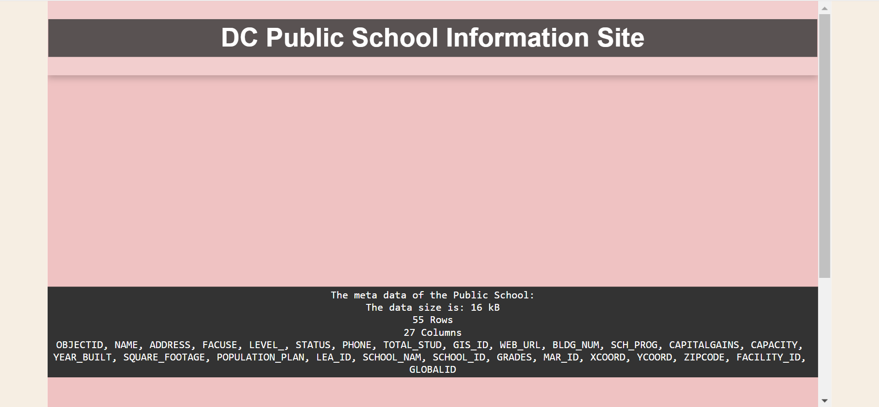

# Convert an image to an SVG using Figma and create a URL link for your svg. Submit the URL link. Use this URL as a background image when displaying the data.

I have downloaded the image of a university from the web browser and opened it from the Figma. I have now exported the file as SVG. This converts the image to SVG.

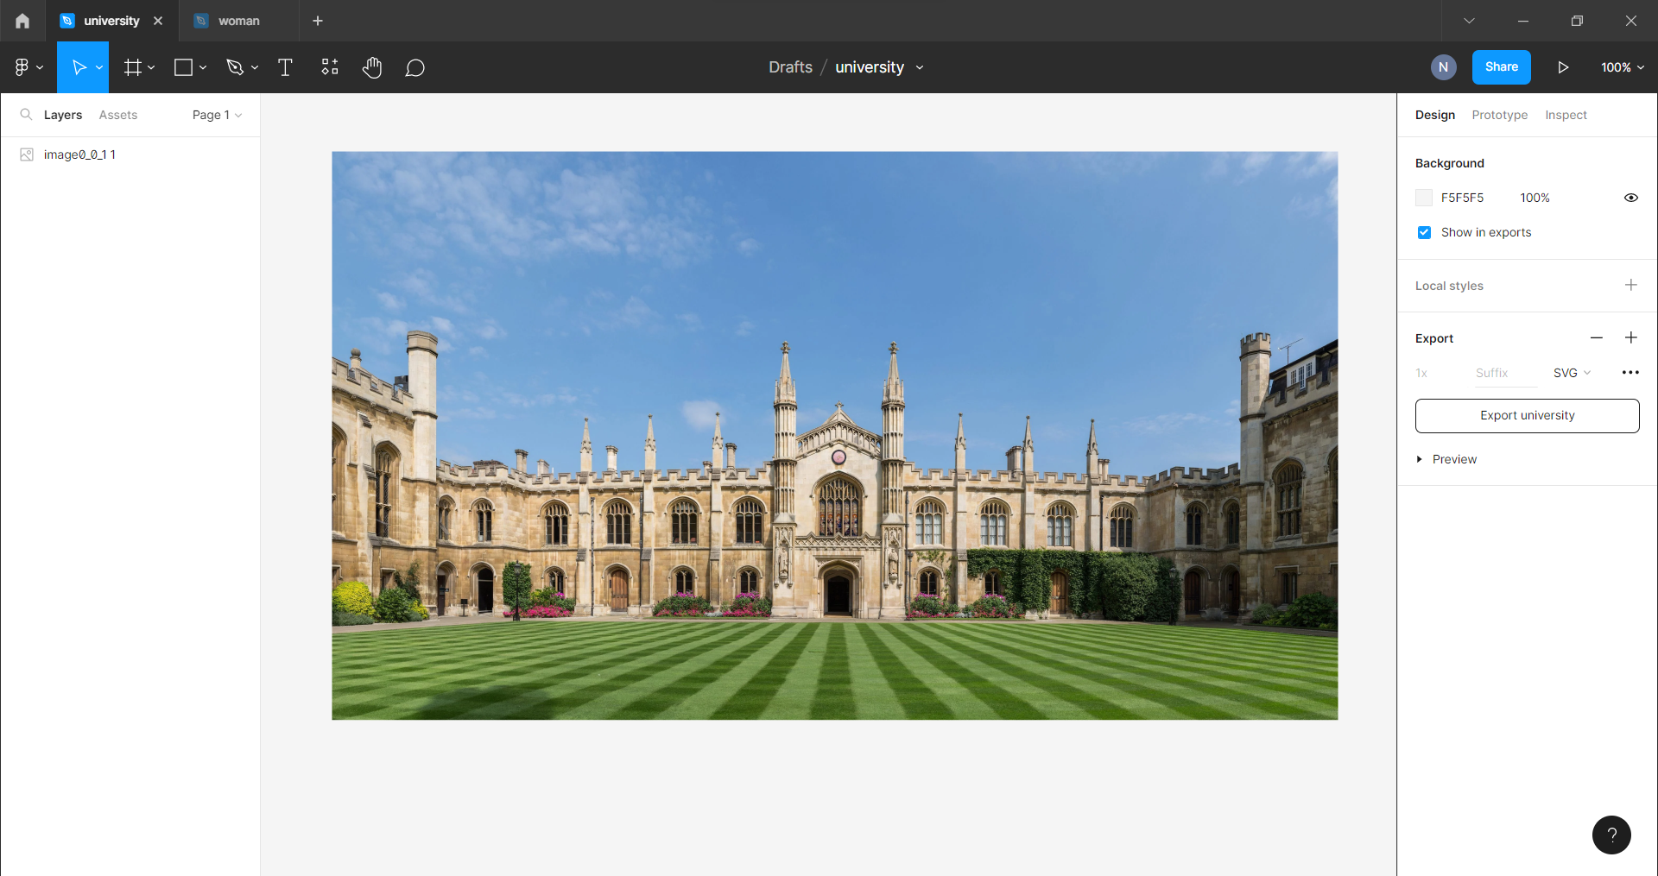

Below is how the SVG file of the image looks like, with tags and image id.

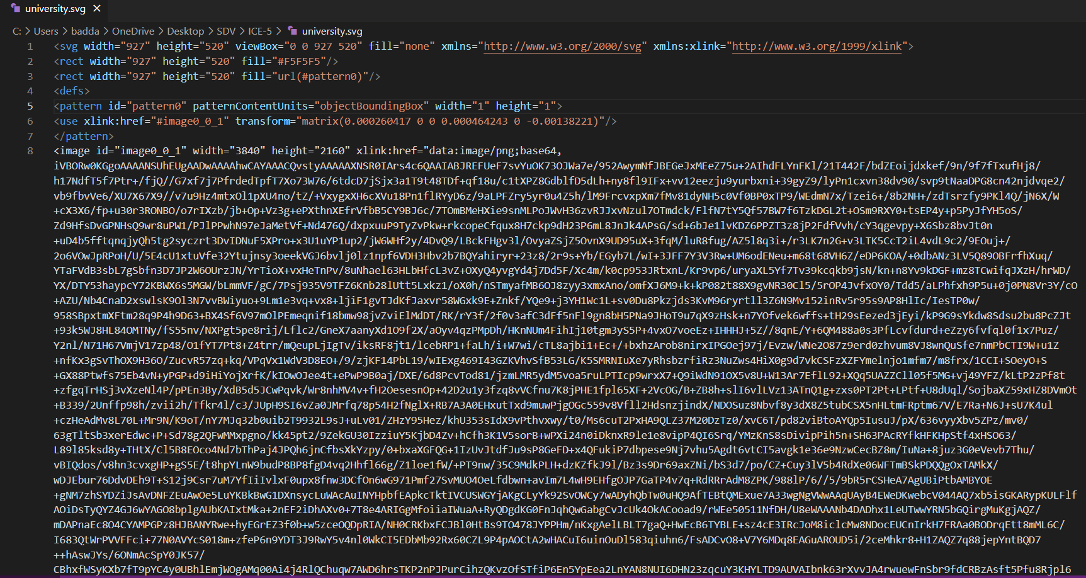

Now I have copied the above SVG content and pasted it on the GitHub Gist file “university.svg” as shown below. Now I create a public gist.

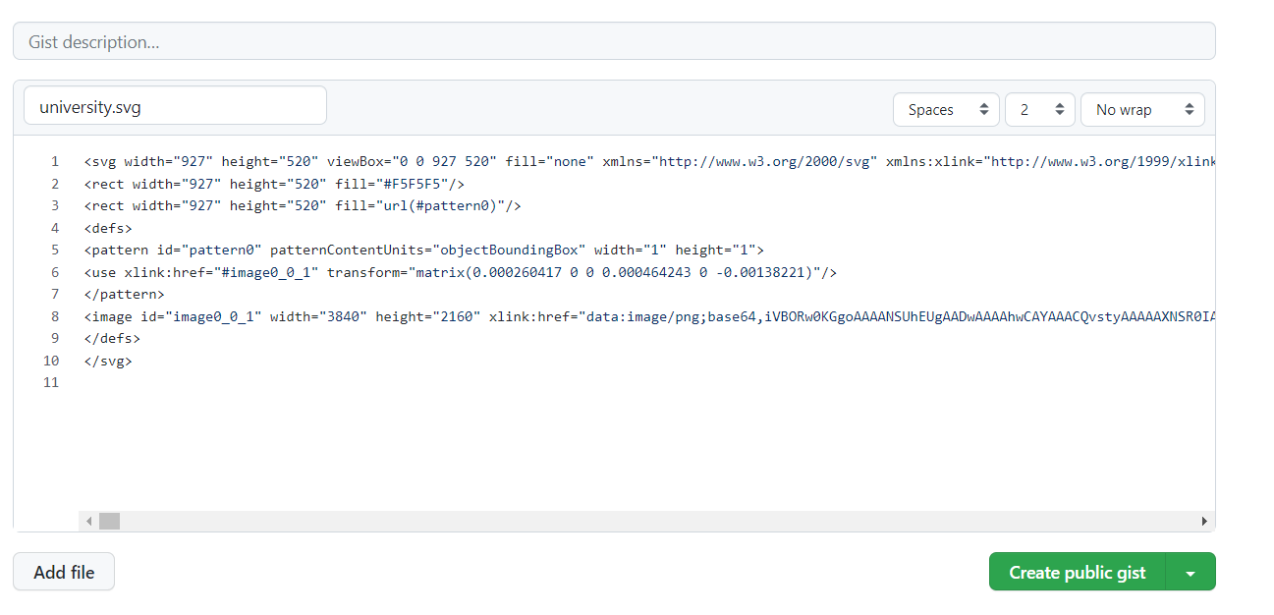

Below is how the file looks after creating the gist. Now click on the “Raw” option and copy the link of the raw SVG.

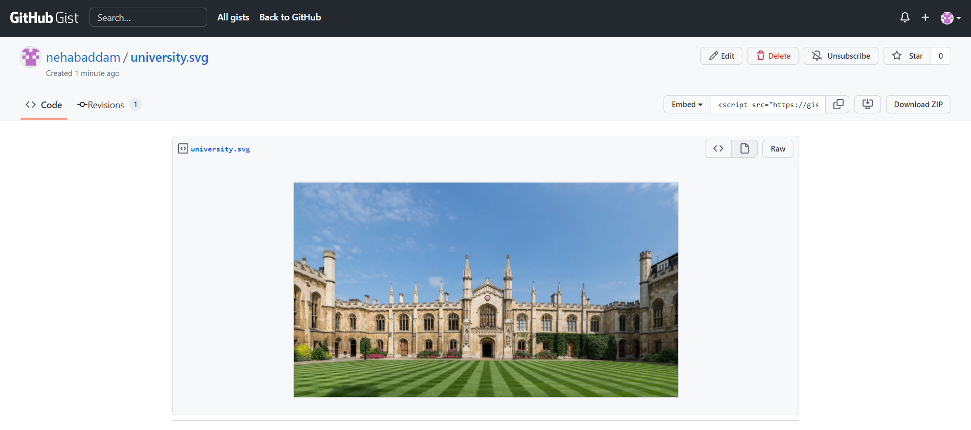

After copying the URL for the image, I have now pasted it in the background image section of the body element in “index.css” file in VizHub. This should make the image in the URL the background for the webpage that we have created, styling the webpage with the background image. 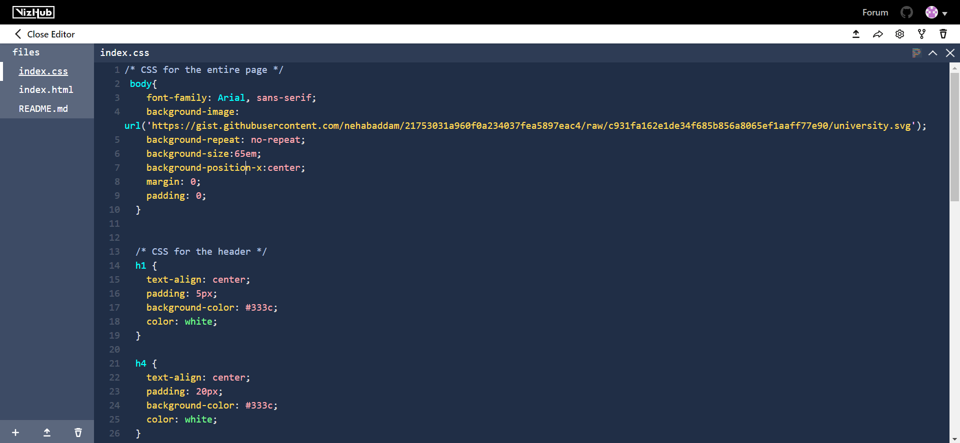

As you can see below, the image appears as the background for the webpage.

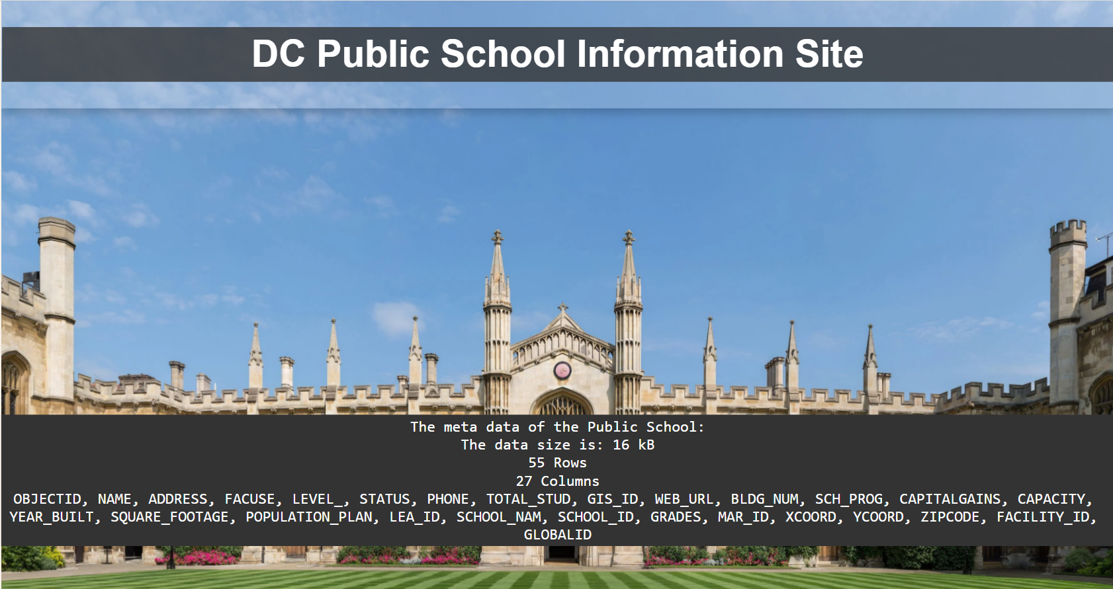

**SVG Link:**

<https://gist.githubusercontent.com/nehabaddam/21753031a960f0a234037fea5897eac4/raw/c931fa162e1de34f685b856a8065ef1aaff77e90/university.svg>

# To view the dataset, add a href tag to your HTML code. Your dataset should appear on your webpage when you tap the hyperlink. submit the code's VizHub URL.

Now I have added a href, to create a hyperlink that opens the dataset. I added CSS styling to make it look like a button “Public School Dataset”.

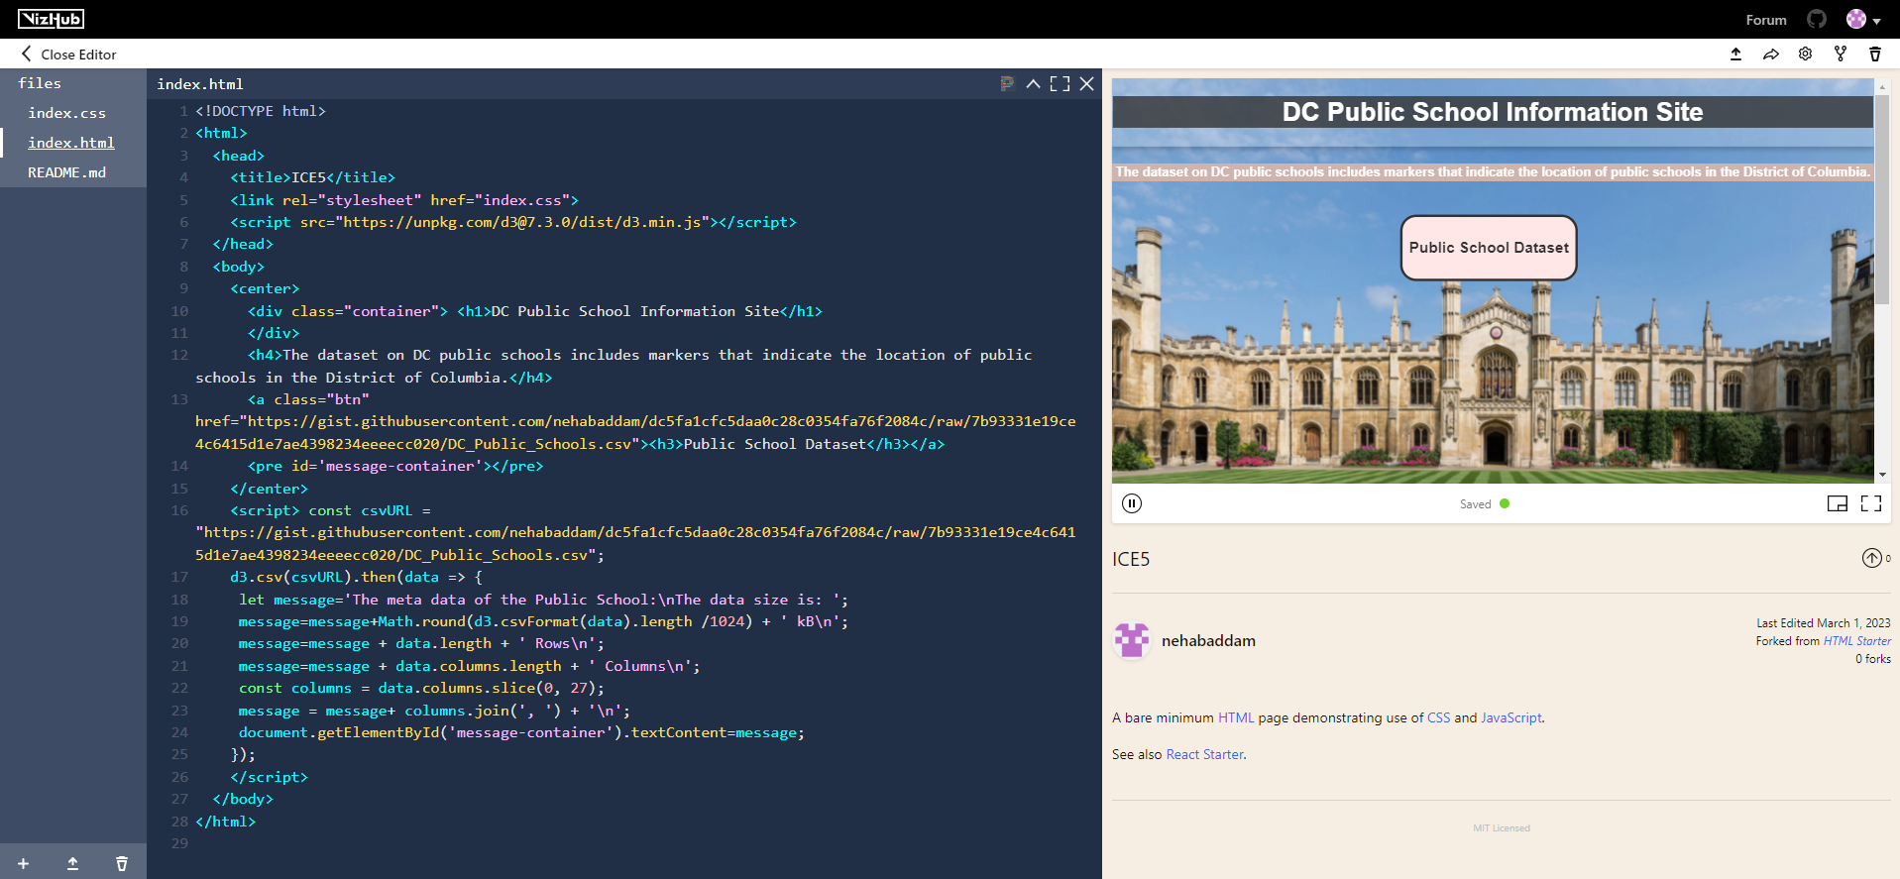

This is now the final Webpage looks like. Now When I click on “Public School Dataset” , a new tab opens in the browser with the GitHub Gist CSV data.

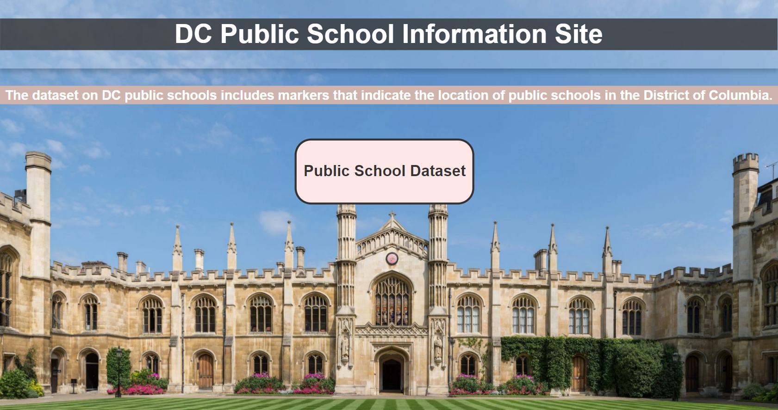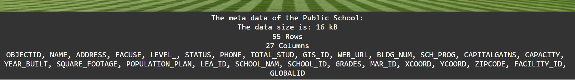

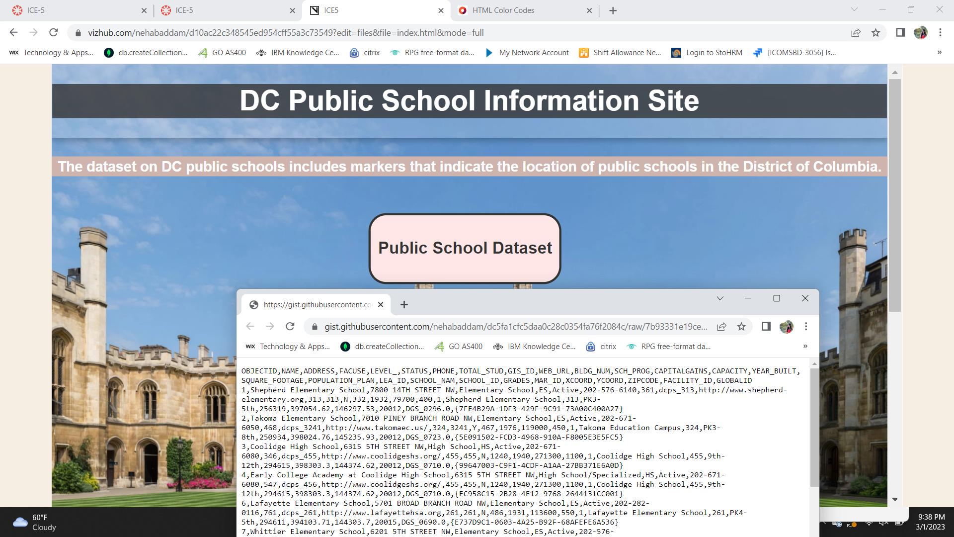

Below is how the CSV content is loaded when we click on the hyperlink.

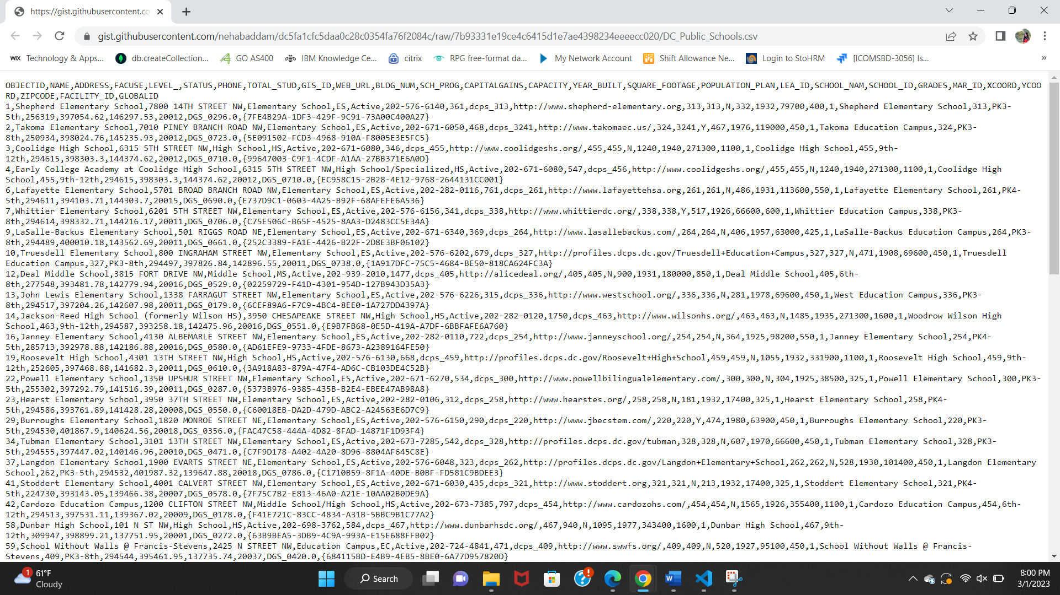

**VizHub Link:**

<https://vizhub.com/nehabaddam/d10ac22c348545ed954cff55a3c73549?edit=files&file=index.css>

**VizHub ID**: nehabaddam